Student’s name | …………………………………………………….…… | Grade | 3
Subject | Computer | Week No. | 9
Lesson Title | Loops | Unit
Worksheet No. ( 9 ) (Answer)

write the correct name of each part.
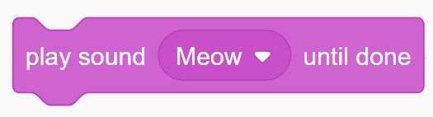



Wait
Say
Play sound
Move
Play sound
Wait
RAM
Say
Move
Good Luck

